HTML & CSS Complete Short Revision Guide

HTML (HyperText Markup Language)

What is HTML?
HTML (HyperText Markup Language) is the standard markup language used to create the structure of web pages.

Basic HTML Structure
<!DOCTYPE html>
<html>
<head>
<meta charset="UTF-8">
<title>My Website</title>
</head>
<body>

</body>
</html>

Tag Description
Tag | Purpose
<!DOCTYPE html> | Declares HTML5 document
<html> | Root element
<head> | Metadata of webpage
<title> | Browser tab title
<body> | Visible webpage content

Headings
<h1>Main Heading</h1>
<h2>Heading</h2>
<h3>Heading</h3>
<h4>Heading</h4>
<h5>Heading</h5>
<h6>Smallest Heading</h6>

- h1 → Largest
- h6 → Smallest

Paragraph
<p>This is a paragraph.</p>

Line Break
<br>

Horizontal Line
<hr>

Text Formatting Tags
<b>Bold</b>
<strong>Important</strong>

<i>Italic</i>
<em>Emphasized</em>

<u>Underline</u>

<mark>Highlight</mark>

<small>Small Text</small>

<del>Deleted</del>

H<sub>2</sub>O

x<sup>2</sup>

Lists

Ordered List
<ol>
<li>Apple</li>
<li>Mango</li>
</ol>

Unordered List
<ul>
<li>Apple</li>
<li>Mango</li>
</ul>

Links
<a href="https://google.com">Google</a>

Open in new tab
<a href="https://google.com" target="_blank">
Google
</a>

Images
<img src="image.jpg" alt="Image">

With size
<img src="image.jpg"
width="250"
height="200">

Tables
<table border="1">

<tr>
<th>Name</th>
<th>Age</th>
</tr>

<tr>
<td>John</td>
<td>20</td>
</tr>

</table>

Table Tags
- table
- tr
- th
- td

Forms
<form>

<input type="text">

<input type="email">

<input type="password">

<input type="number">

<input type="date">

<input type="radio">

<input type="checkbox">

<textarea></textarea>

<select>
<option>India</option>
<option>USA</option>
</select>

<button>Submit</button>

</form>

Common Input Types
text
password
email
number
date
radio
checkbox
file
color
range
submit
reset

HTML Attributes
id
class
href
src
alt
style
title
width
height

Semantic HTML Tags
<header>

<nav>

<main>

<section>

<article>

<aside>

<footer>

Advantages
- Better SEO
- Better accessibility
- Easy to understand code

Div vs Span

Div
- Block element
- Starts from a new line
<div>Hello</div>

Span
- Inline element
- Doesn't start a new line
<span>Hello</span>

Block elements start on a new line and stretch the full width of their container, while inline elements fit side-by-side within text lines, occupying only the space their content strictly needs

CSS (Cascading Style Sheets)

What is CSS?
CSS is used to style HTML elements and improve the appearance of web pages.
Example
h1{
color:red;
}

Ways to Apply CSS

Inline CSS
<h1 style="color:red;">Hello</h1>

Internal CSS
<style>
h1{
color:red;
}
</style>

External CSS
<link rel="stylesheet" href="style.css">

CSS Syntax
selector{

property:value;

}

Example
p{
color:blue;
font-size:20px;
}

CSS Selectors

Element Selector
p{

}

Class Selector
.box{

}

ID Selector
#header{

}

Universal Selector
*{

}

Group Selector
h1,p{

}

Colors
color:red;

color:#ff0000;

color:rgb(255,0,0);

Background
background-color:yellow;

background-image:url(bg.jpg);

Fonts
font-size:20px;

font-family:Arial;

font-weight:bold;

font-style:italic;

Text Properties
text-align:center;

text-decoration:none;

text-transform:uppercase;

letter-spacing:2px;

line-height:2;

CSS Box Model
Margin

Border

Padding

Content

Example
div{

margin:20px;

padding:15px;

border:2px solid black;

}

Width & Height
width:300px;

height:200px;

Border
border:2px solid black;

border-radius:10px;

Display Property
display:block;

display:inline;

display:inline-block;

display:flex;

display:grid;

display:none;

Position
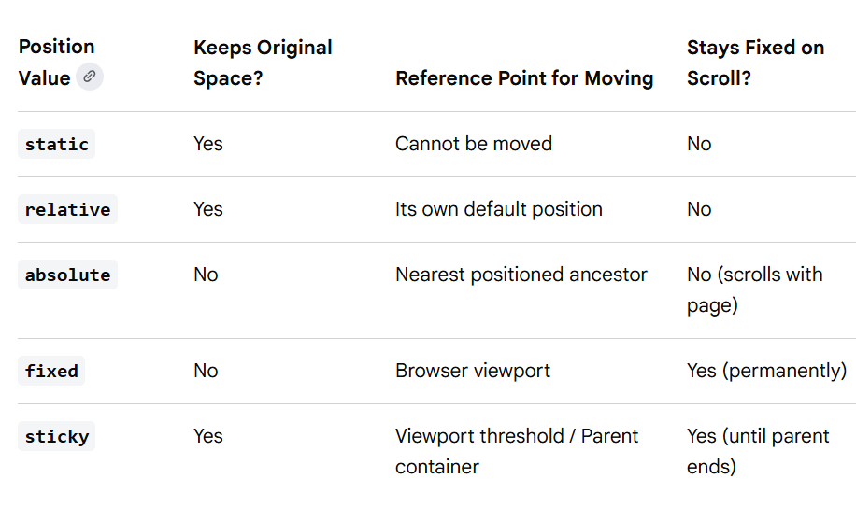

Flexbox
Enable Flexbox
display:flex;

Important Properties
justify-content:center;

align-items:center;

flex-direction:row;

flex-direction:column;

gap:20px;

flex-wrap:wrap;

CSS Grid
display:grid;

grid-template-columns:1fr 1fr;

gap:20px;

Overflow
overflow:hidden;

overflow:auto;

overflow:scroll;

Z-index
z-index:10;

Works only on positioned elements.

Shadows
Box Shadow
box-shadow:0 0 10px gray;

Text Shadow
text-shadow:2px 2px red;

Cursor
cursor:pointer;

Hover
button:hover{

background:blue;

}

Transition
button{

transition:0.3s;

}

button:hover{

background:red;

}

Transform
transform:scale(1.1);

transform:rotate(45deg);

transform:translateX(20px);

Animation
@keyframes move{

from{
left:0;
}

to{
left:200px;
}

}

Media Queries (Responsive Design)
@media(max-width:768px){

body{

background:red;

}

}

CSS Units
px
%
em
rem
vh
vw

Frequently Used CSS Properties
color
background
width
height
margin
padding
border
border-radius
display
position
top
left
right
bottom
font-size
font-family
font-weight
text-align
box-shadow
cursor
transition
transform
opacity
overflow

HTML vs CSS
HTML | CSS
Creates structure | Adds styling
Uses tags | Uses selectors
Defines content | Defines appearance

Frequently Asked Viva Questions

1. What is HTML?
HTML is a markup language used to create the structure of web pages.

2. What is CSS?
CSS is a stylesheet language used to style HTML elements.

3. Difference between HTML and CSS?
- HTML creates the webpage structure.
- CSS styles the webpage.

4. Difference between id and class?
id | class
Unique | Reusable
Used once | Used many times
Selected using # | Selected using .

5. Difference between div and span?
div | span
Block element | Inline element
Starts on new line | Same line

6. Difference between Margin and Padding?
- Margin → Space outside border
- Padding → Space inside border

7. What is Box Model?
The CSS Box Model consists of:
Content → Padding → Border → Margin

8. What is Flexbox?
A one-dimensional layout system used to align items in rows or columns.

9. What is CSS Grid?
A two-dimensional layout system used to arrange items in rows and columns.

10. What are Semantic Tags?
Semantic tags describe the meaning of content and improve SEO and accessibility.
Examples:
<header>
<nav>
<main>
<section>
<article>
<footer>

5-Minute Quick Revision Checklist
✅ HTML document structure
✅ Headings
✅ Paragraphs
✅ Text formatting tags
✅ Lists
✅ Links
✅ Images
✅ Tables
✅ Forms
✅ Input types
✅ Attributes (id, class, href, src)
✅ Semantic tags
✅ div vs span
✅ CSS syntax
✅ Selectors
✅ Colors
✅ Background
✅ Fonts
✅ Text properties
✅ Box Model
✅ Margin vs Padding
✅ Width & Height
✅ Border & Border-radius
✅ Display property
✅ Position property
✅ Flexbox
✅ Grid
✅ Overflow
✅ Z-index
✅ Hover
✅ Transition
✅ Transform
✅ Animation
✅ Media Queries
✅ HTML vs CSS differences
✅ Frequently asked interview and viva questions

